|  |
| --- |
| Book Store Web Application |
| Prakash V MERN Stack Developer |
| Web Application Link : https://book-store-djp.netlify.app  RSVP TO: Click or Copy Past this Link to Open |
|  |

**LANDING PAGE :**

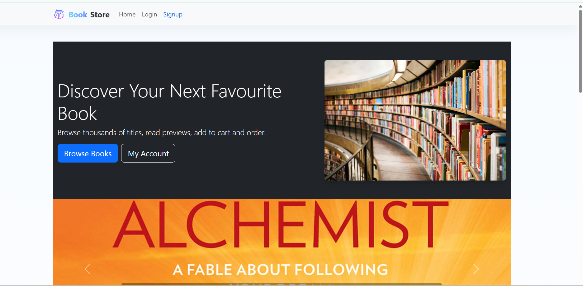

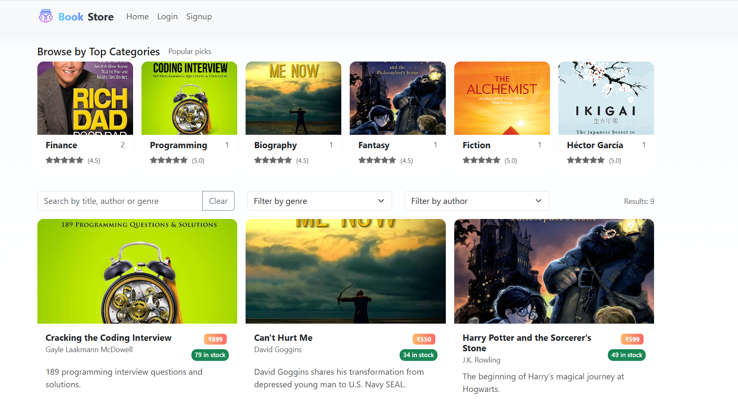

Initial public page with navigation to Login and Register options for users and admins.

LOGIN PAGE :

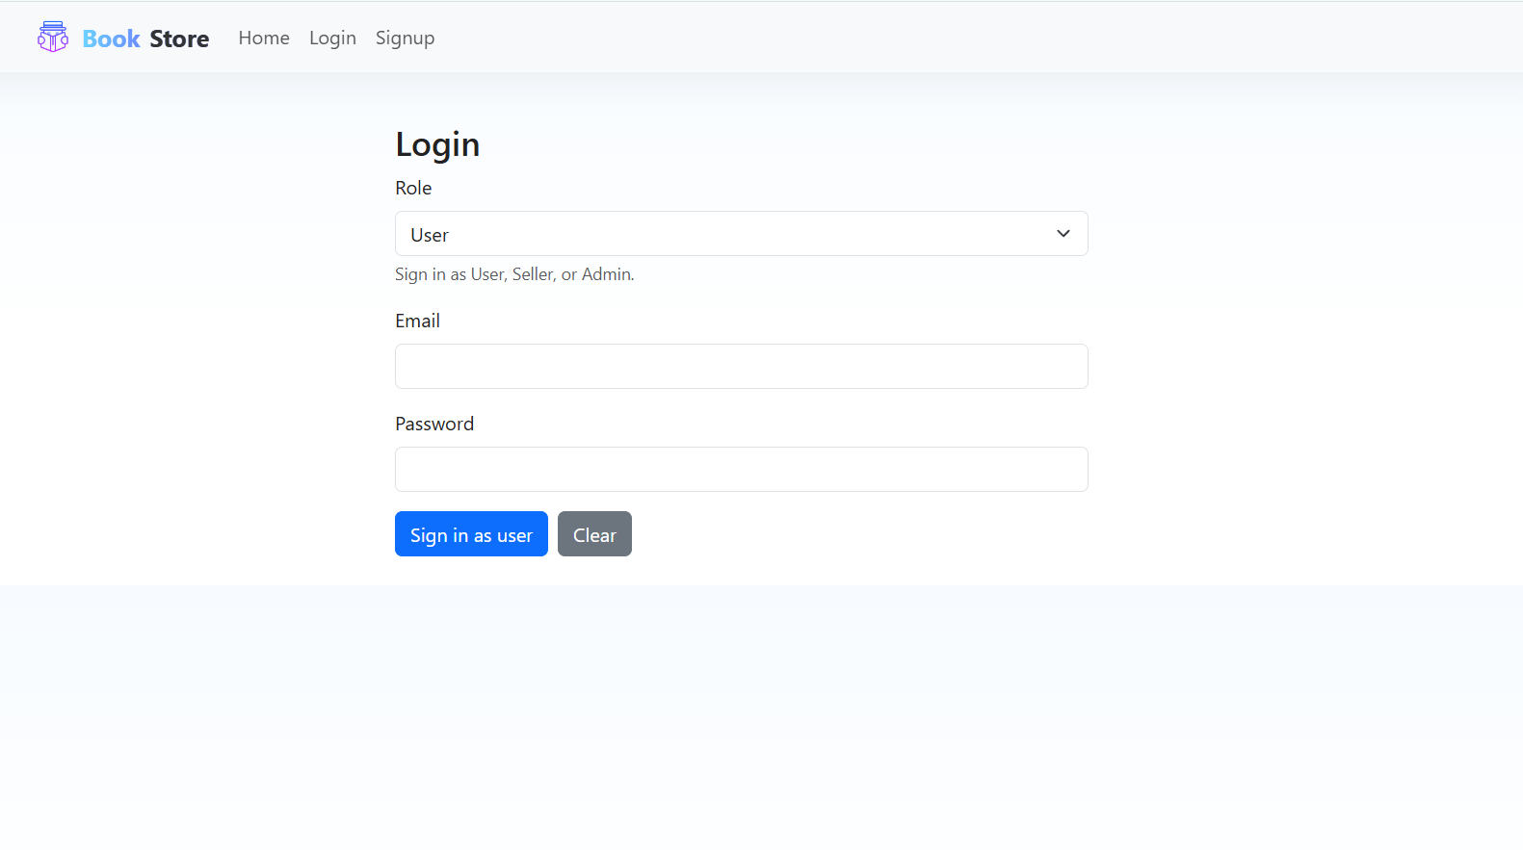

Authenticates users/admins and redirects them to their respective Home Page after verifying credentials.

REGISTRATION PAGE :

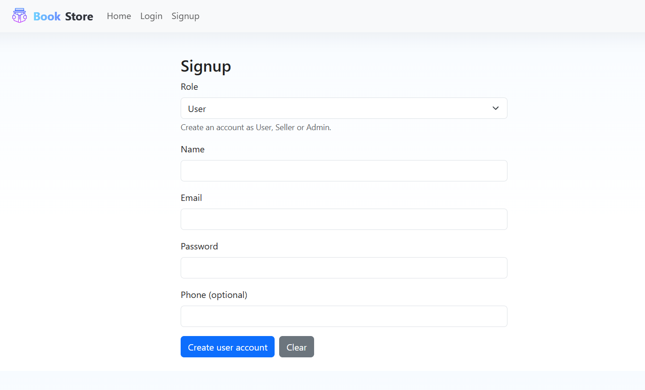

Allows new users to register as either USER or SELLER by entering basic details and selecting a role.

User HomePage:

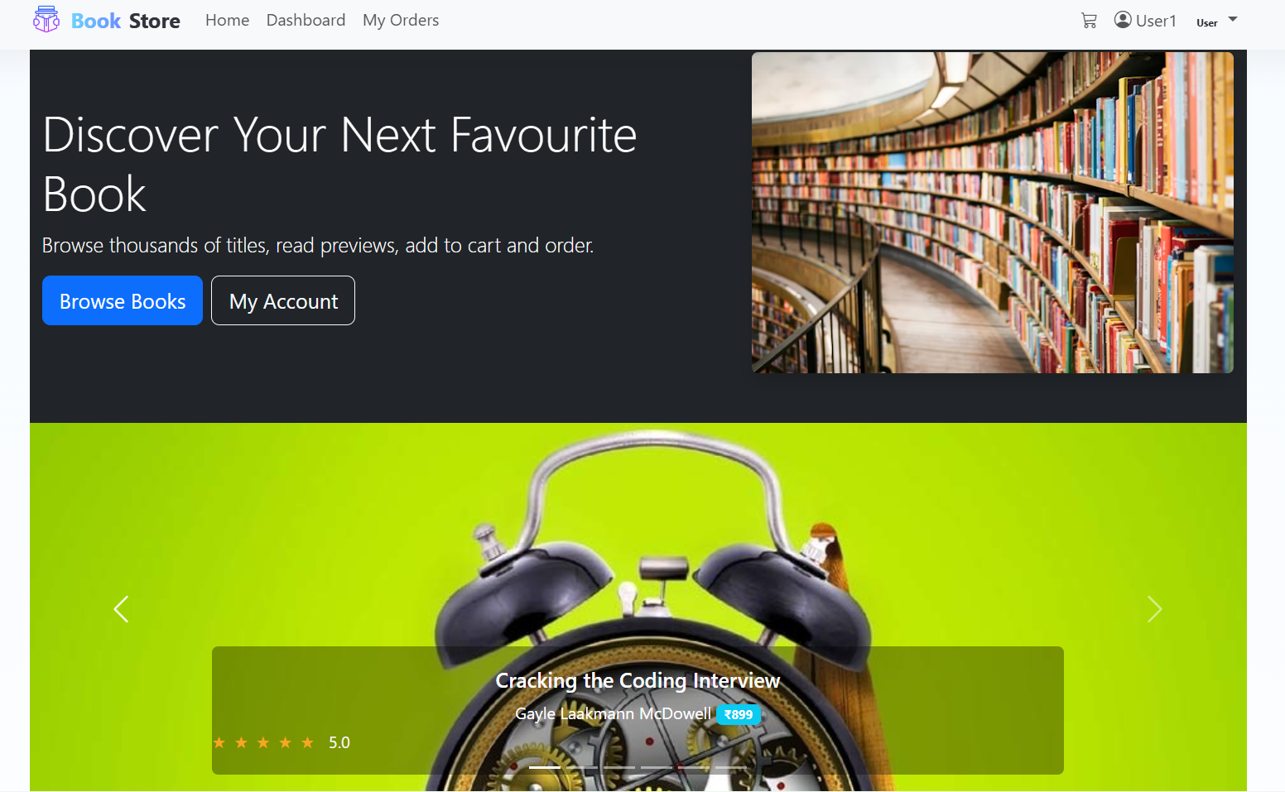

Book Section:

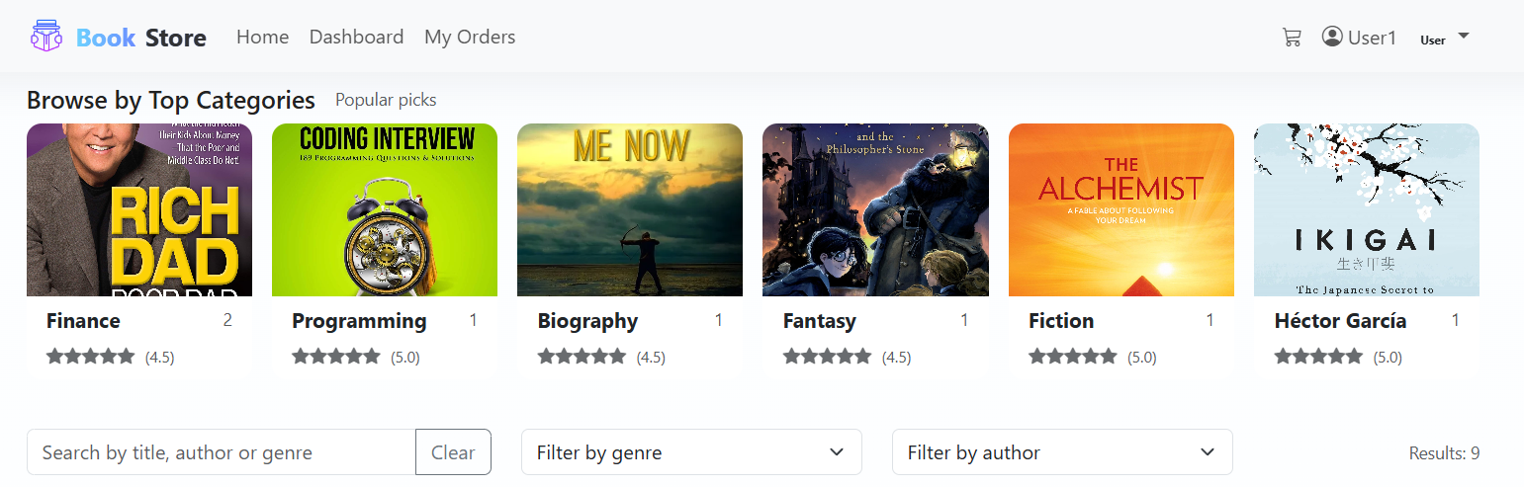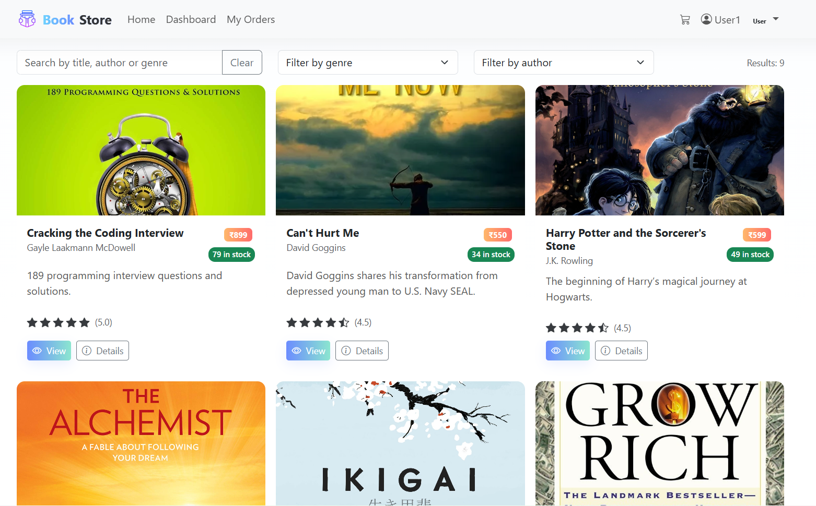

Book View Page:

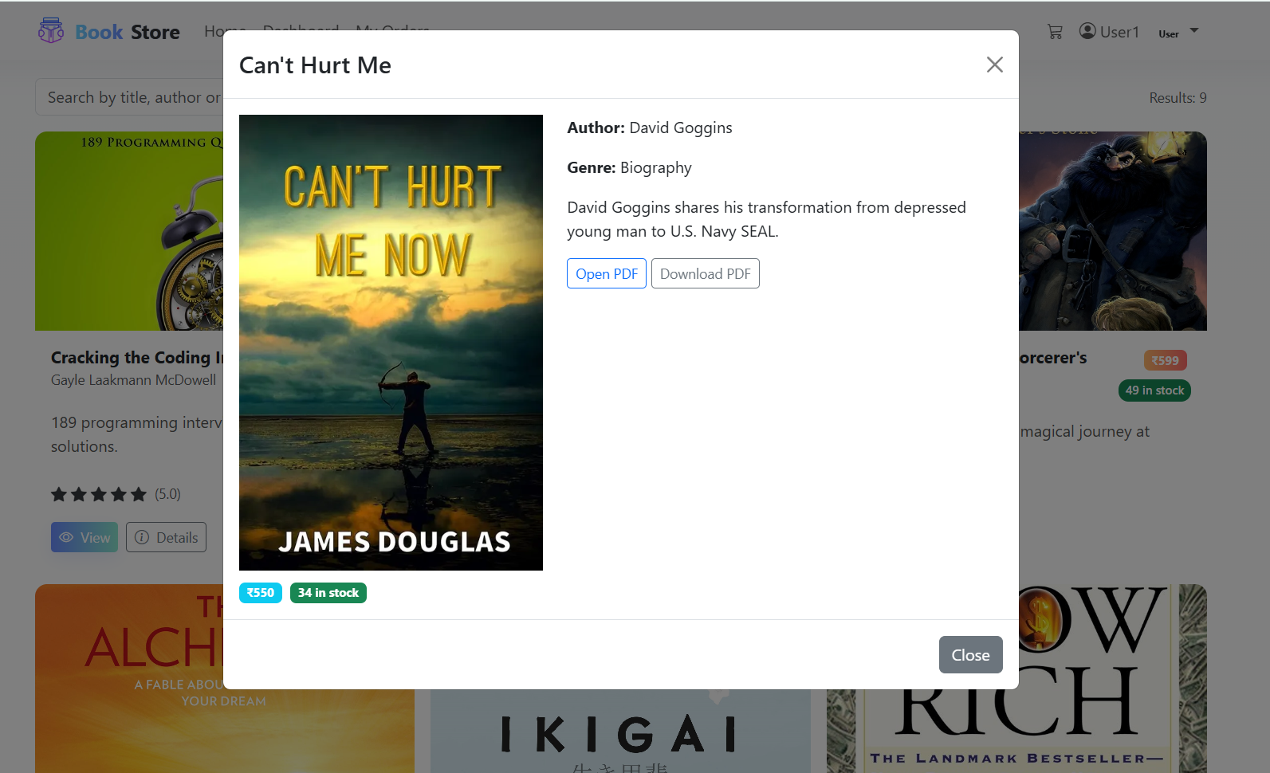

**Book Detail Page:**

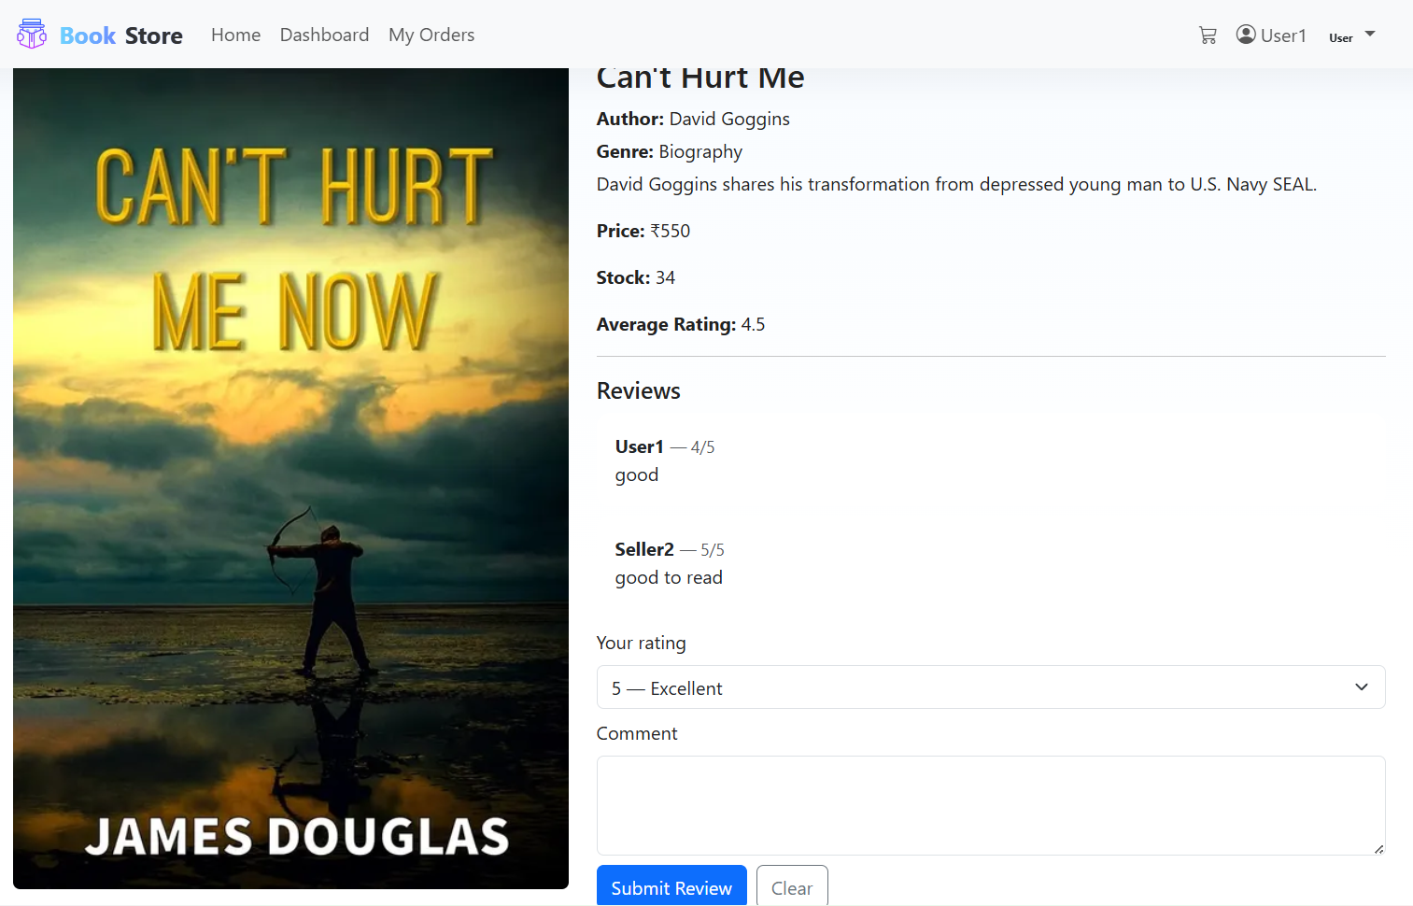

User’s Order Page:

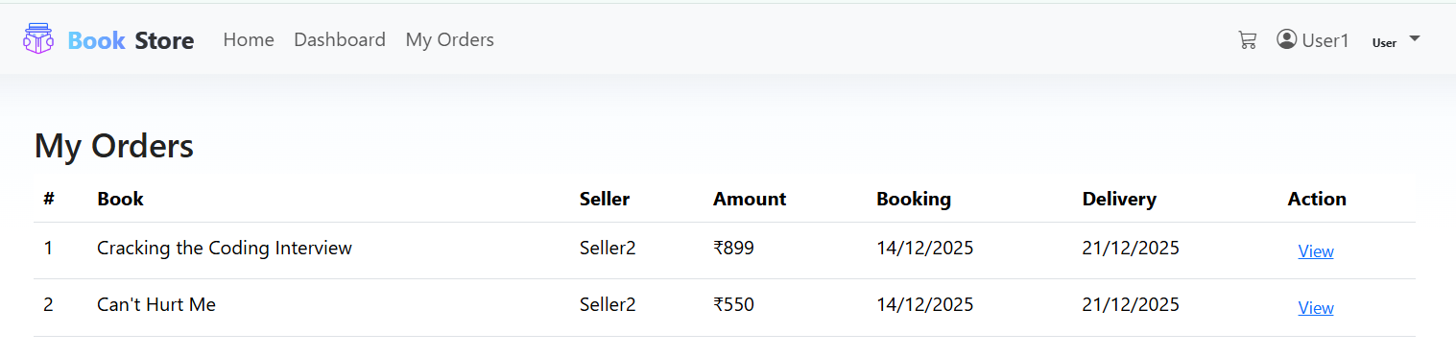

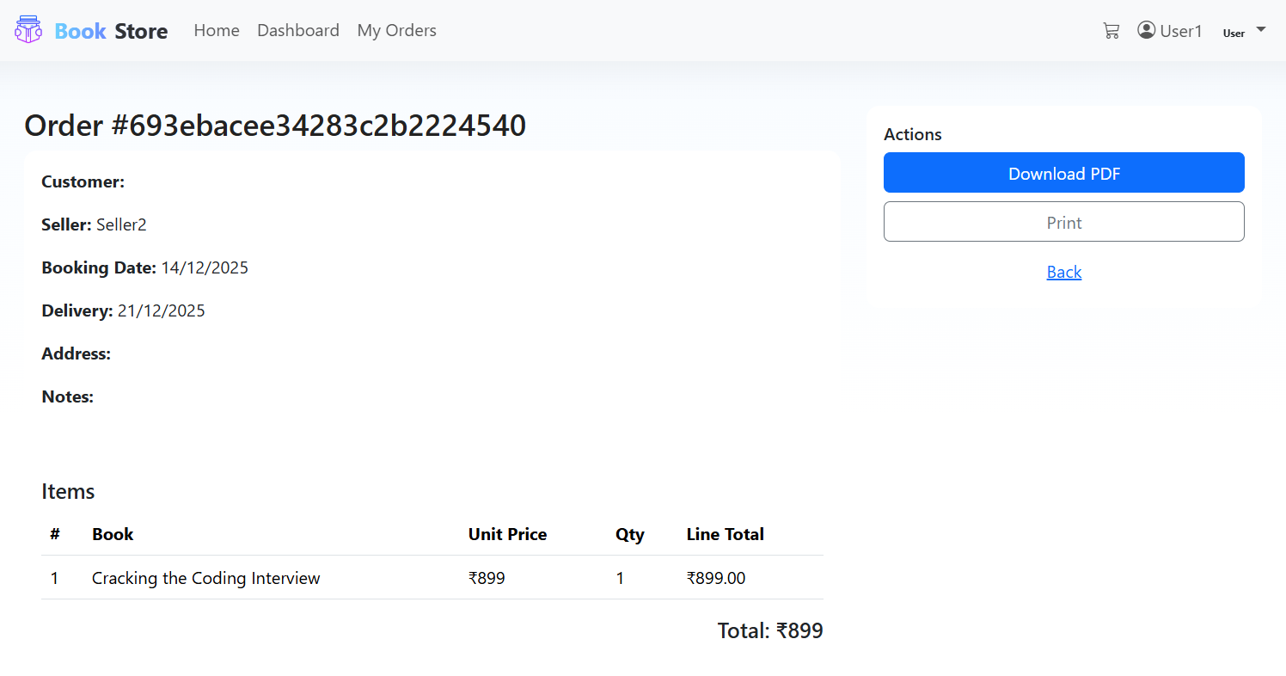

**Print or Download Order:**

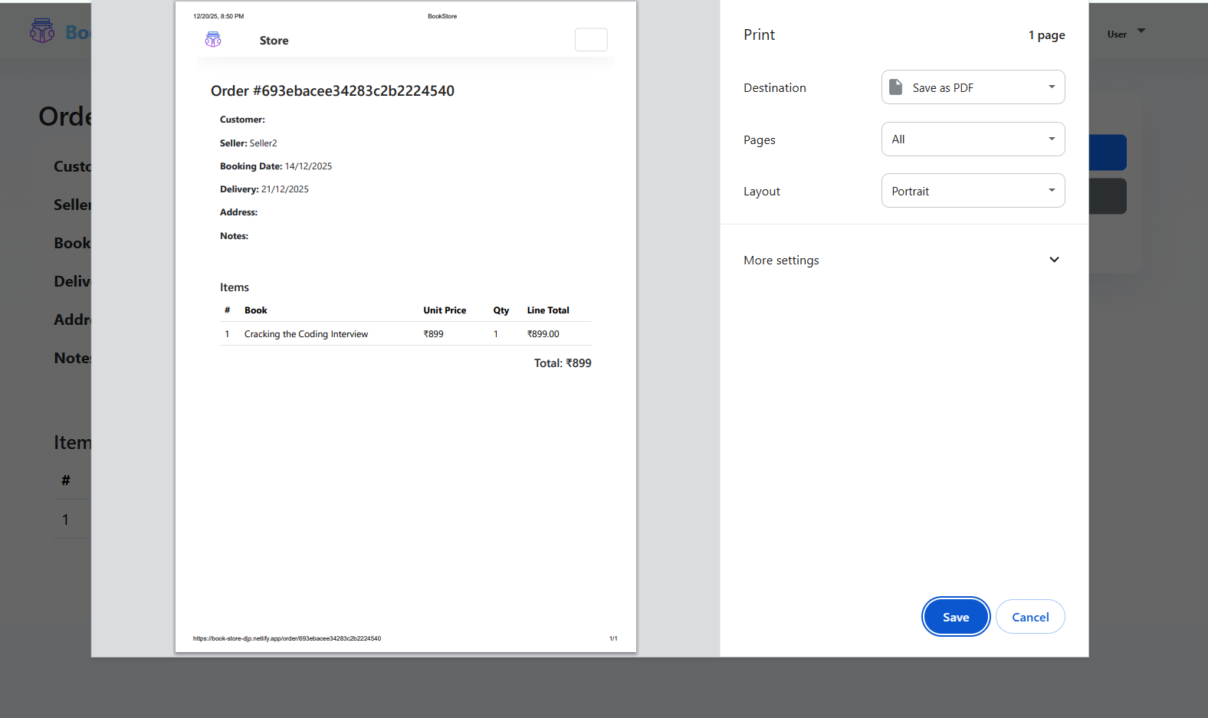

**User Dashboard:**

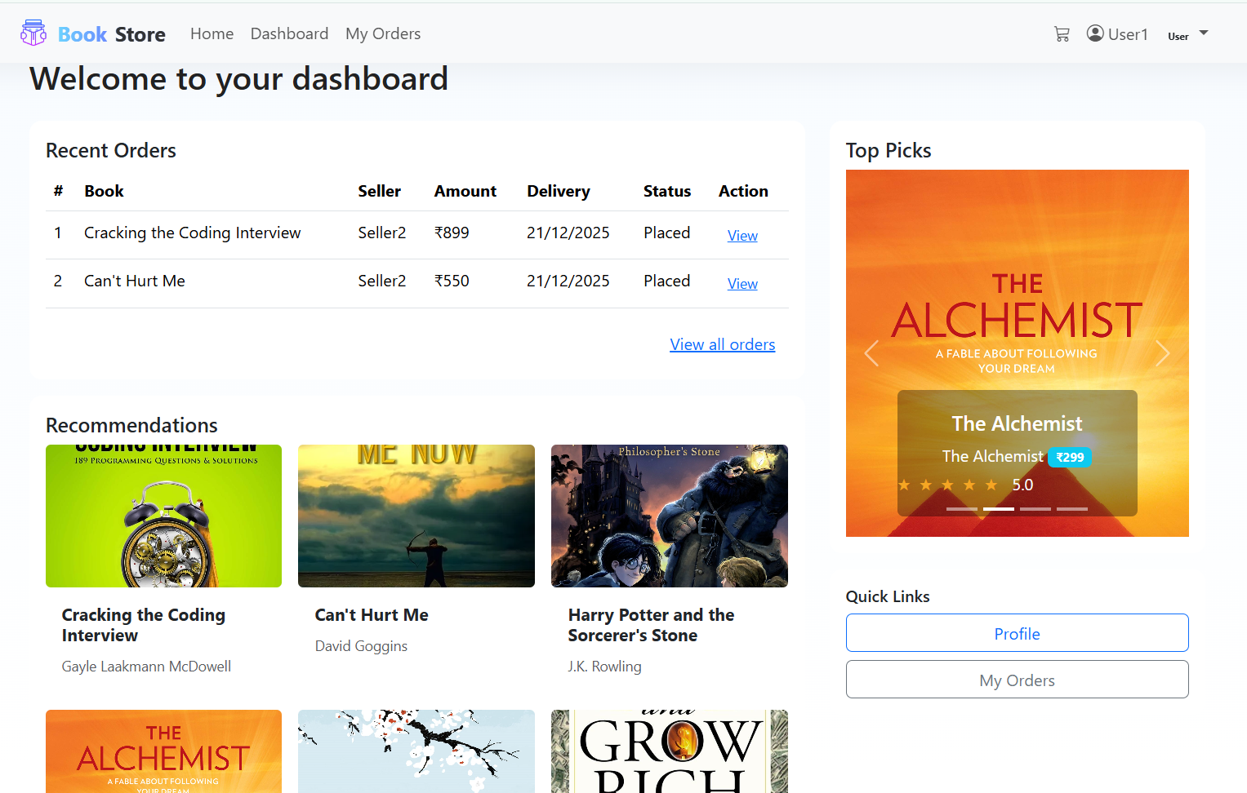

**User Profile:**

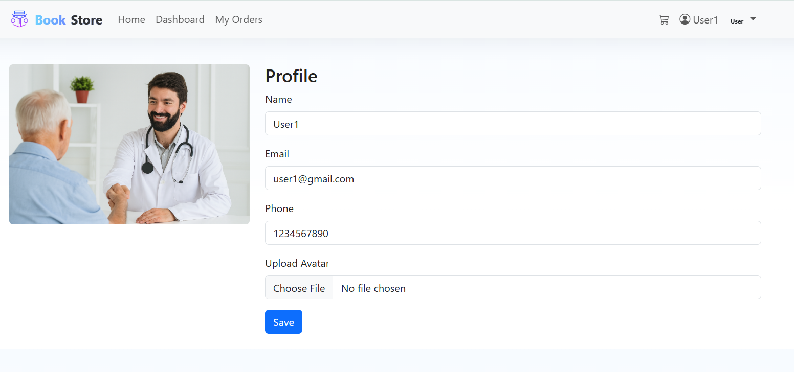

**Book Cart Page:**

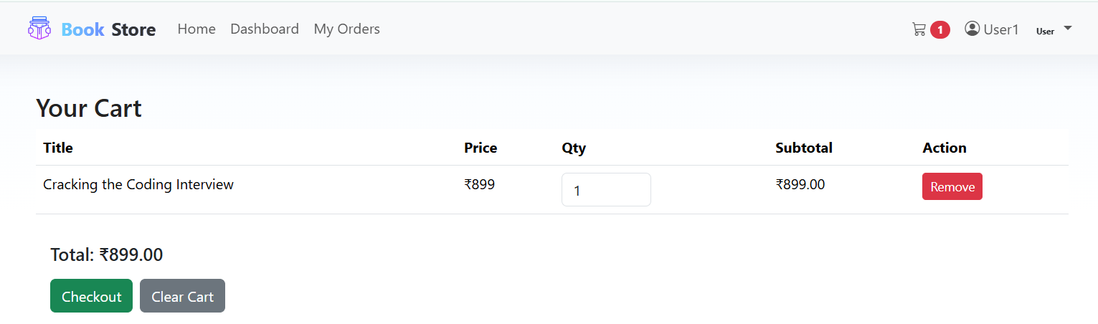

Seller Login Page:

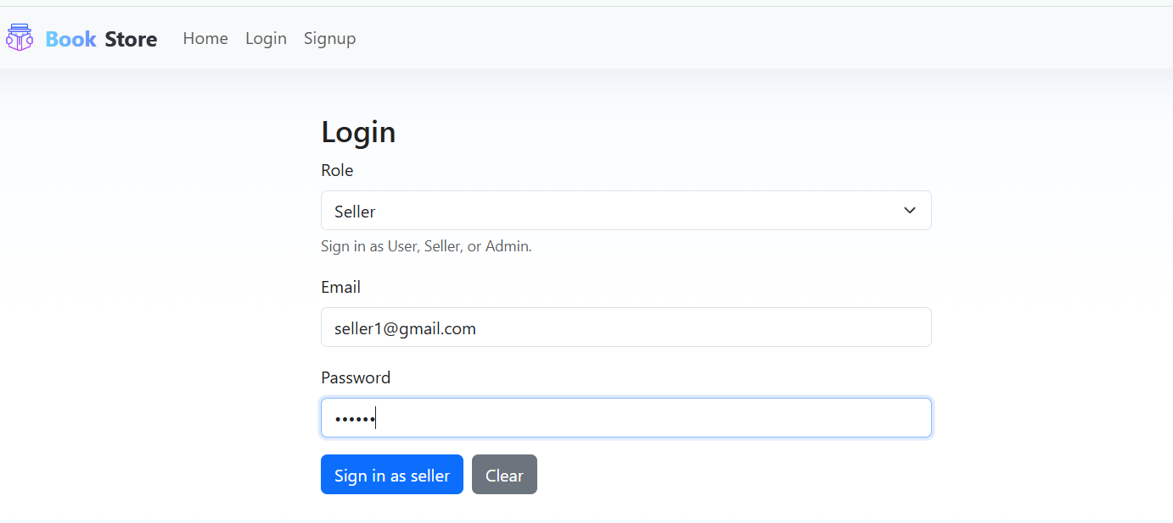

**Seller Home Page:**

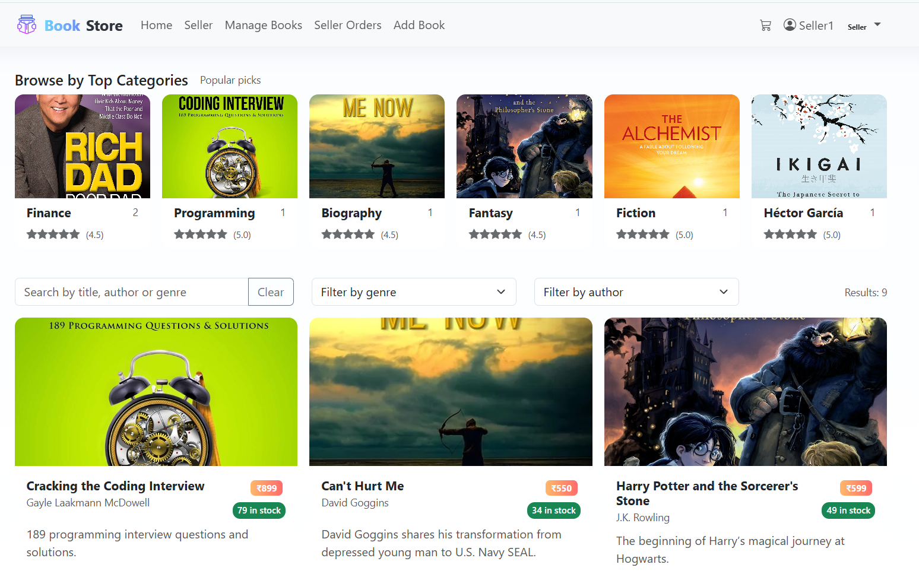

Seller Dashboard:

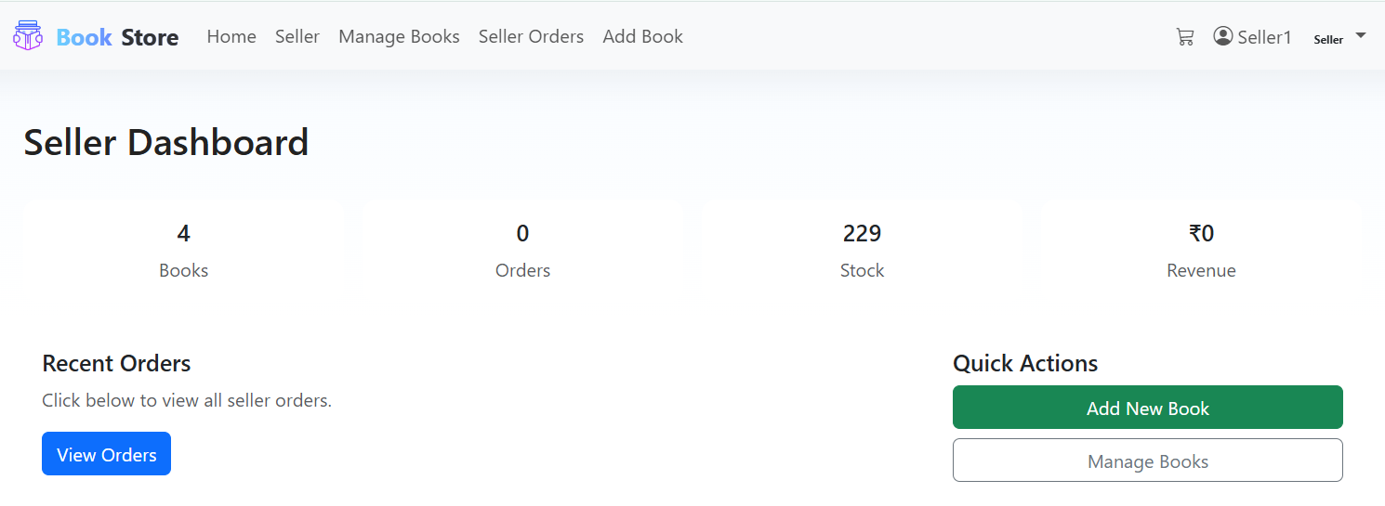

**Seller Product’s:  
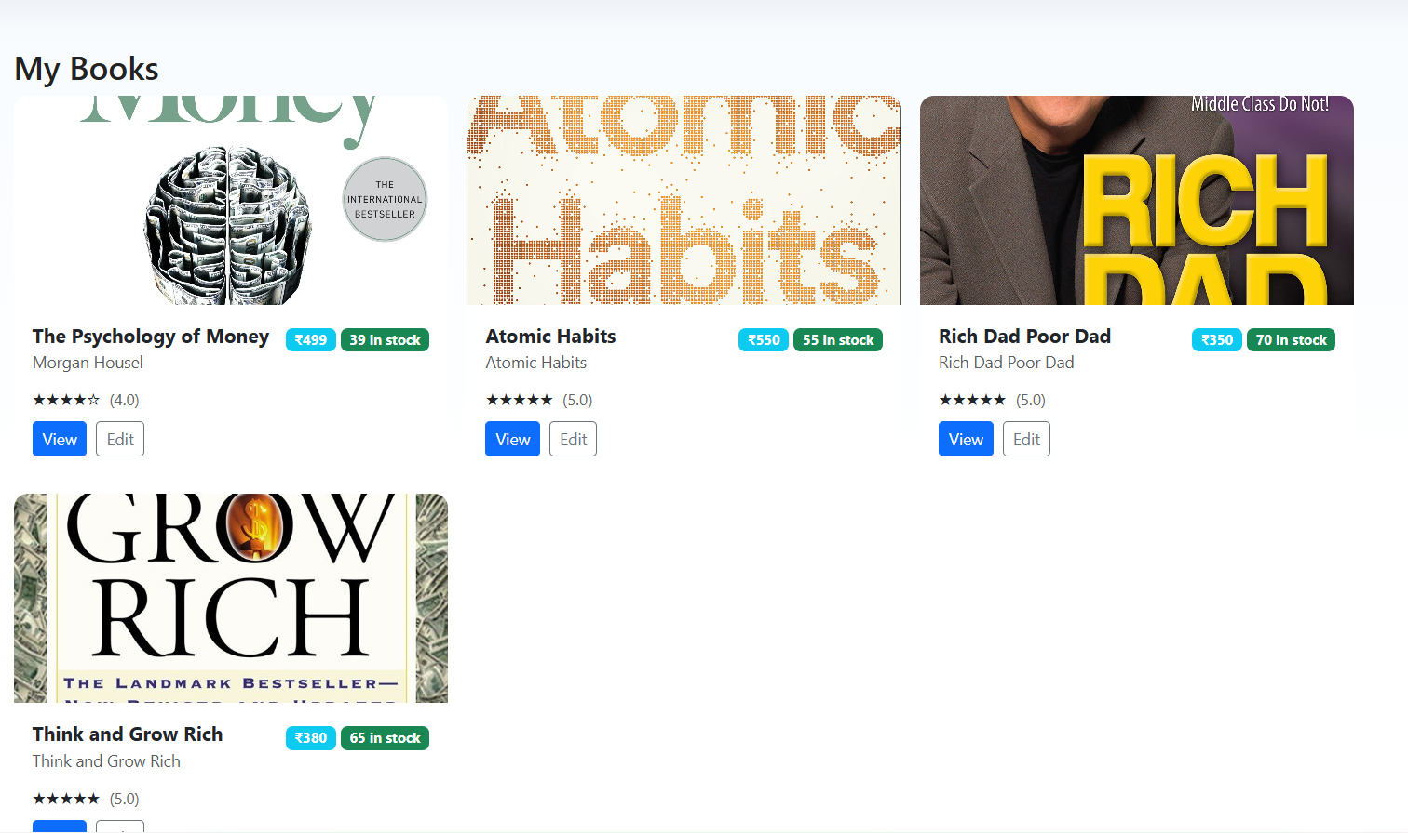**

**Seller Order Page:**

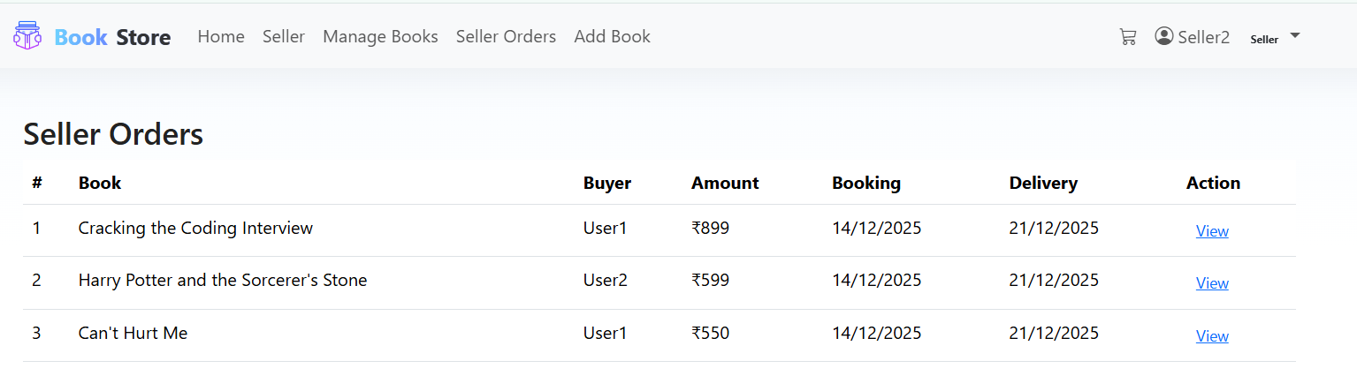

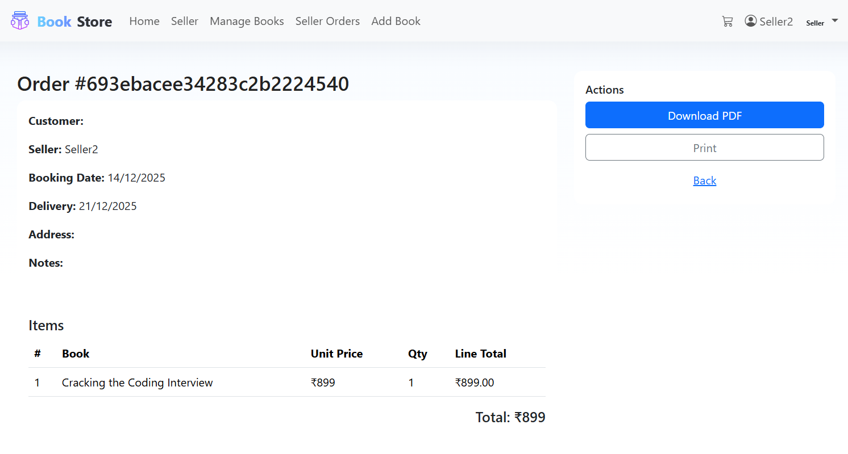

**Seller Add Book :**

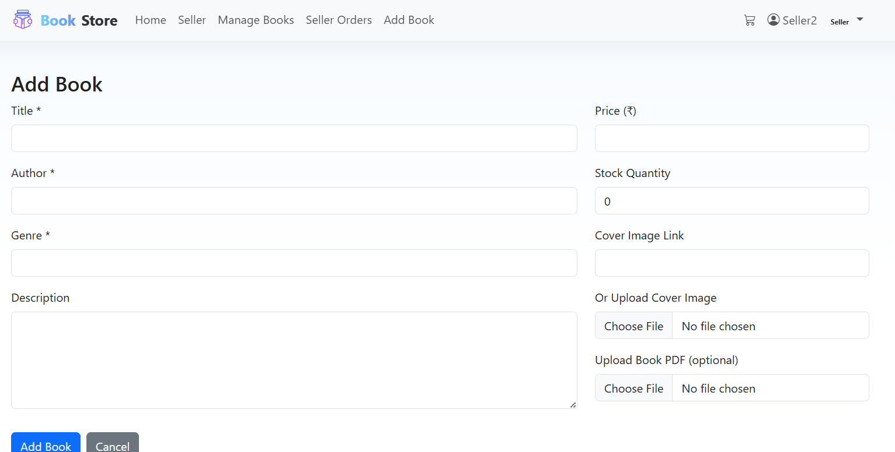

**Seller Profile Page:** 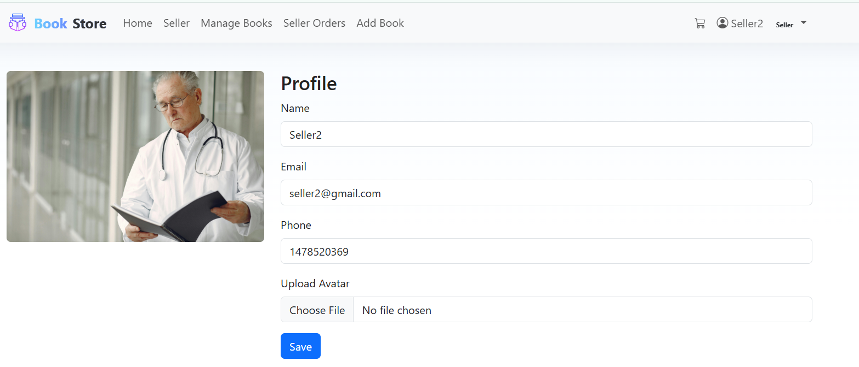

**Admin Login Page:**

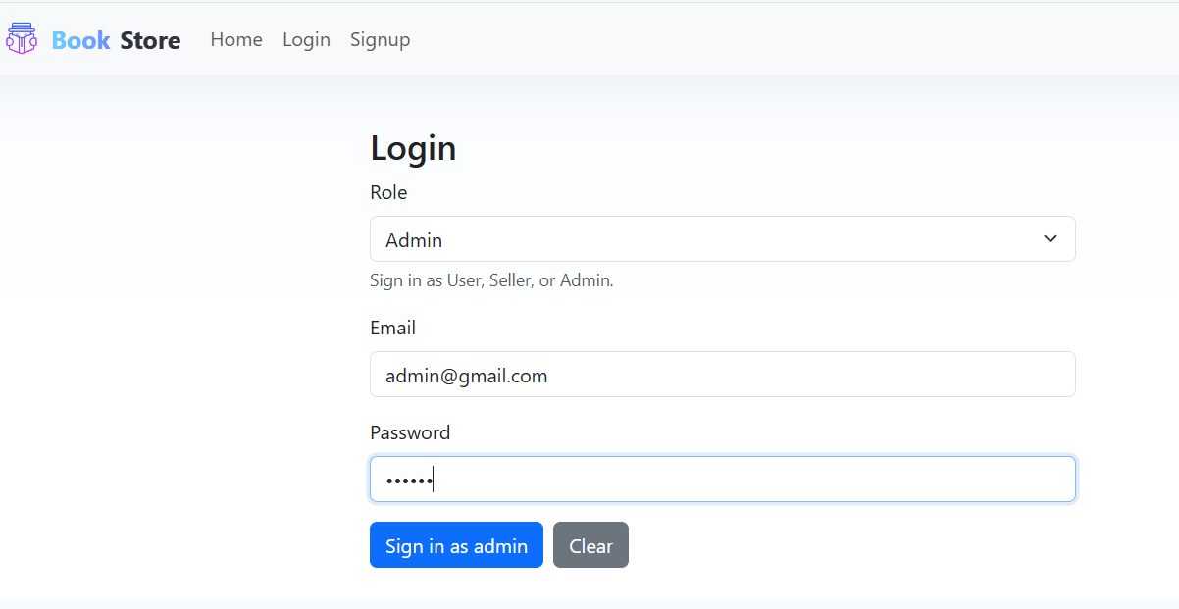

**Admin Home Page:**

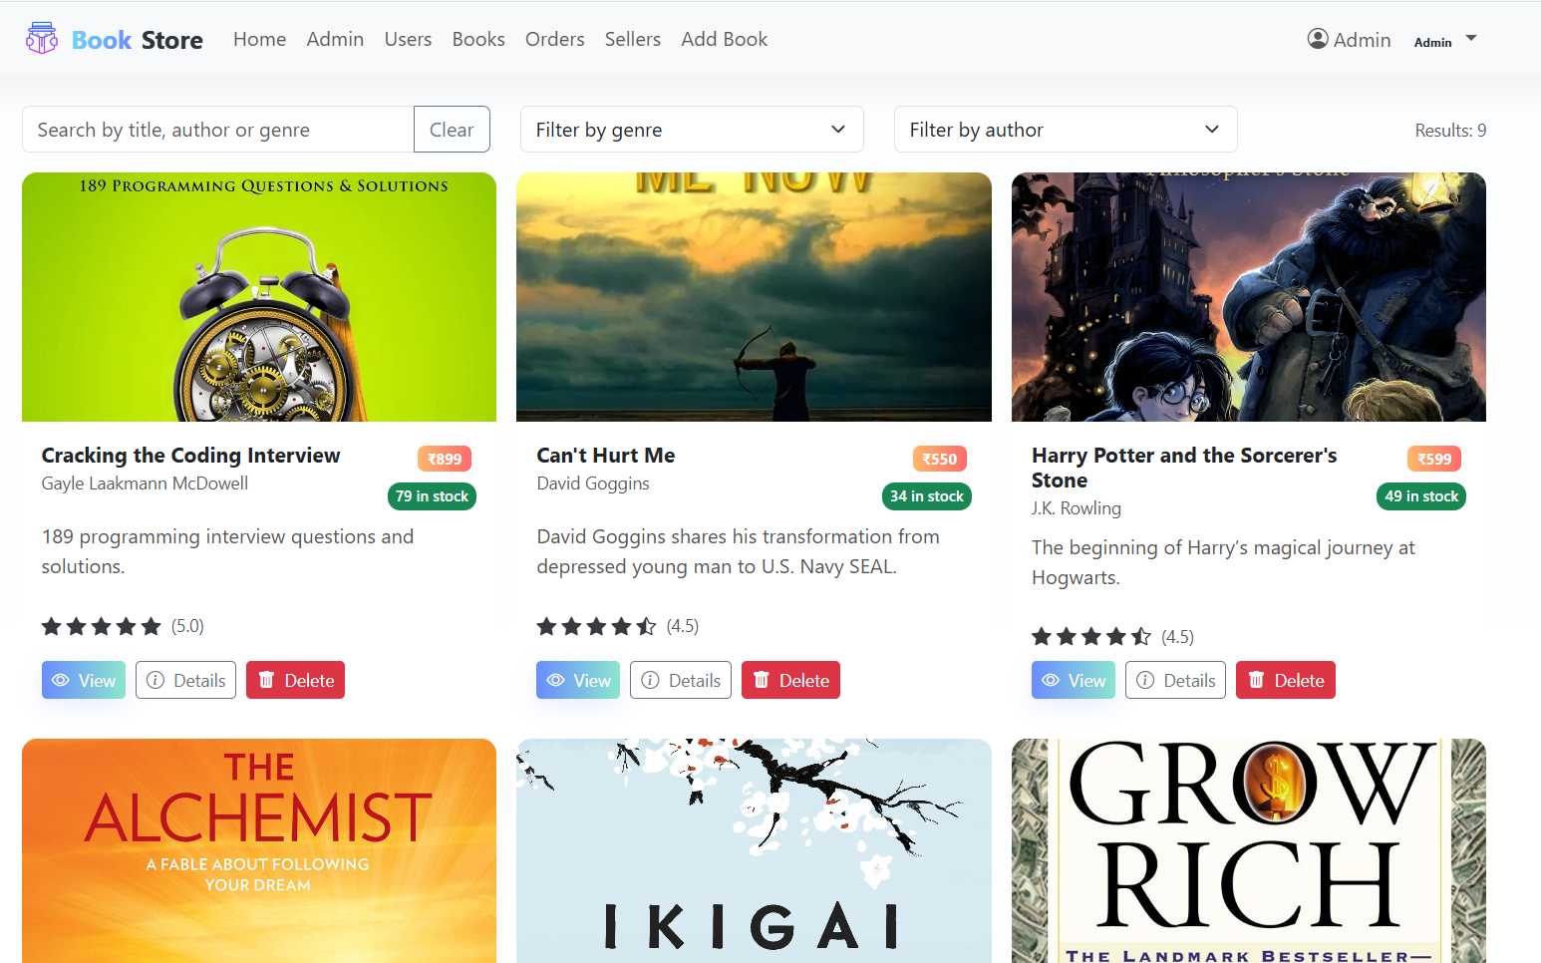

**Admin Dashboard:**

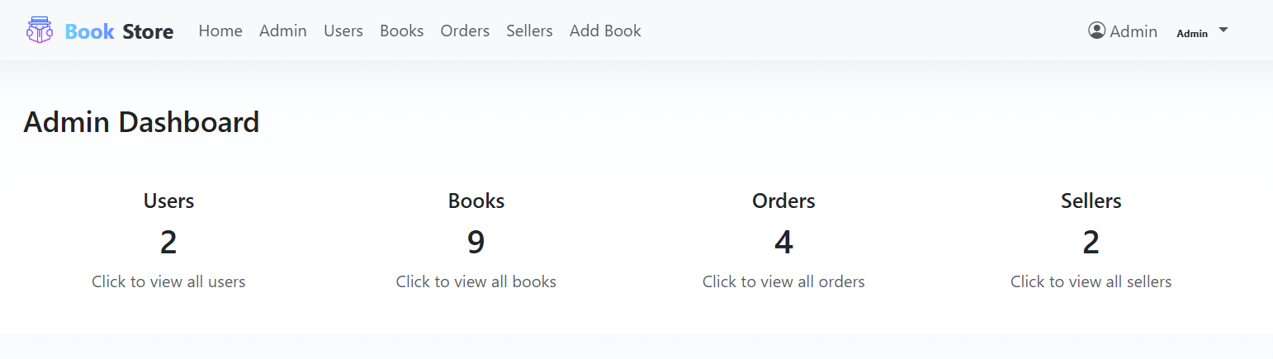

**Admin Manage Books:**

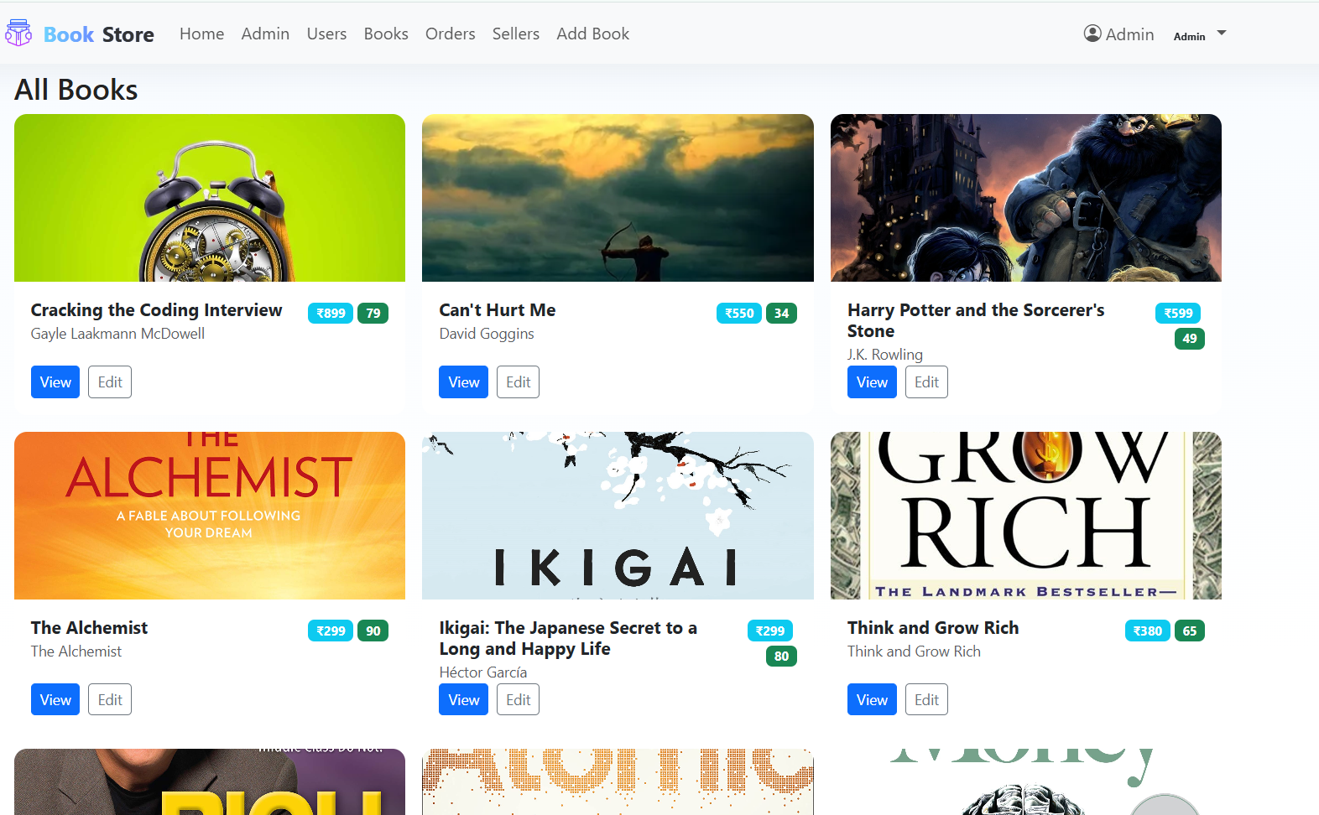

**All Order Page:**

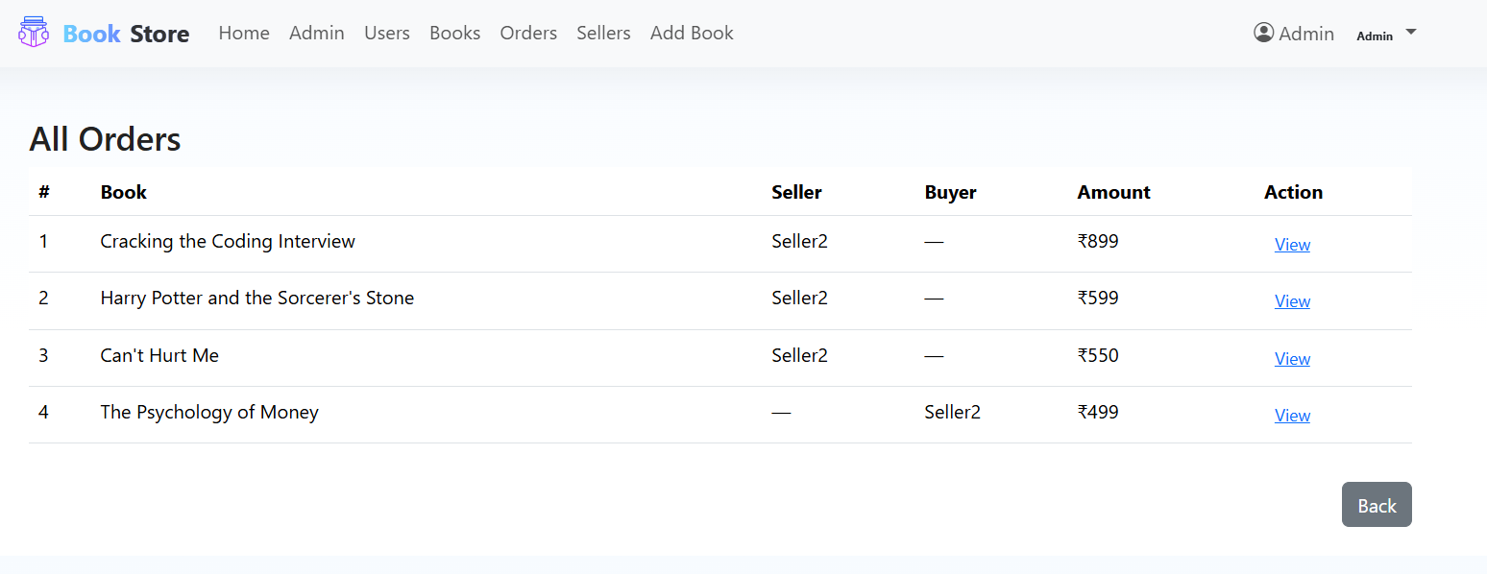

**All User’s Page:**

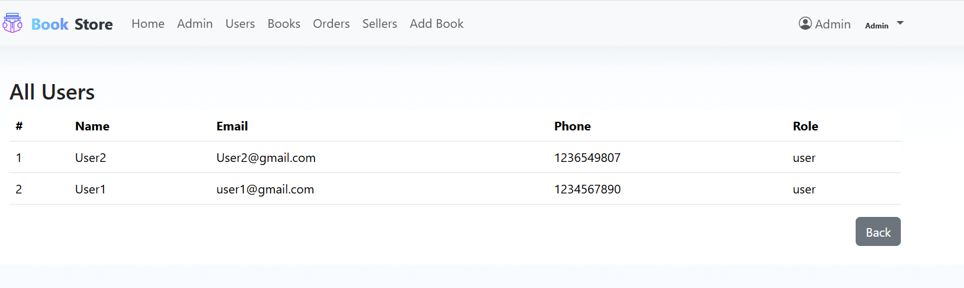

**All Seller’s:**

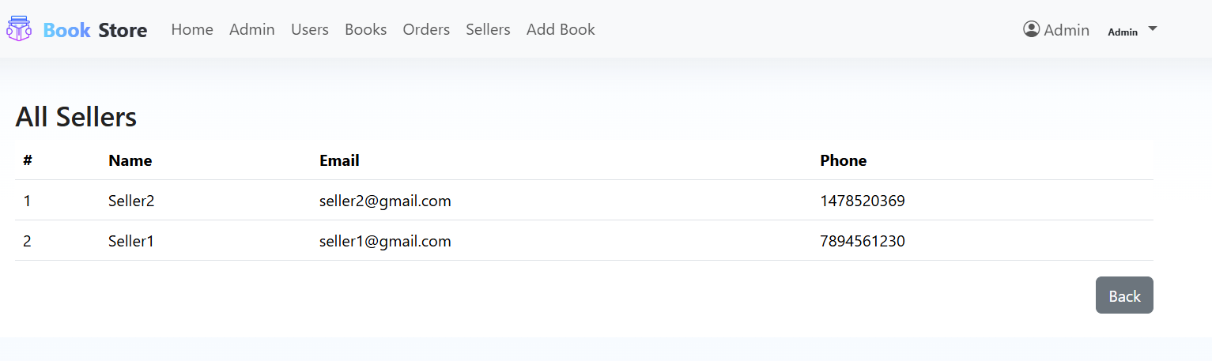

**Admin Add Book:**

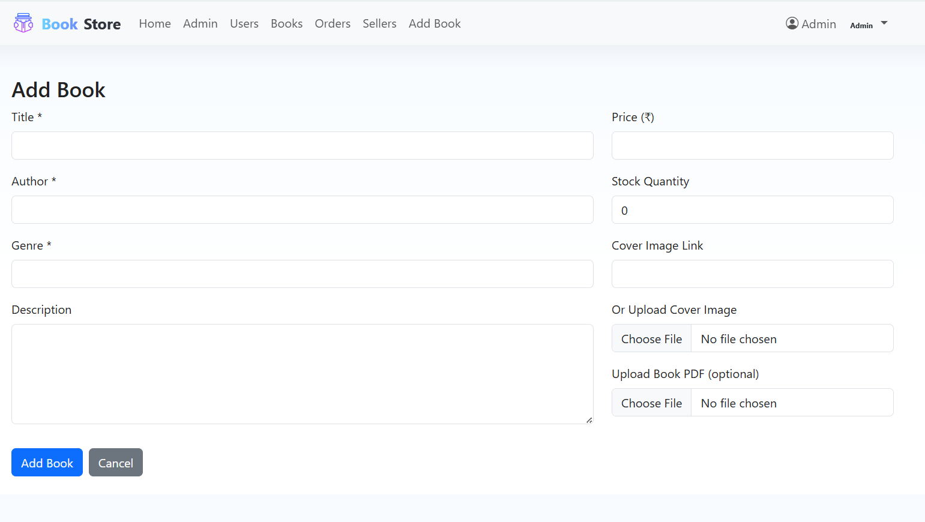

**Admin Profile:**

